WEEK 2

**1.**

Question 1

Identifying suspicious behavior at an airport is a complex problem. In this case study, what was one strategy for decomposing this problem into a smaller, more manageable problem?

**1 / 1 point**



Design an algorithm that counts how often luggage is left unattended.



Define a specific type of suspicious behavior in quantifiable terms.



Design an algorithm that can differentiate between airport staff and travelers.



Use machine learning to track which parts of the airport is the busiest.

**Correct**

Correct! In order to solve a complex problem like airport surveillance, it’s helpful to breakdown the problem into something specific and quantifiable.

**2.**

Question 2

When designing an algorithm that will detect unattended luggage, what kind of information would likely **NOT** be relevant to this problem?

**1 / 1 point**



The types of clothing people in an airport are wearing.



The distance between attended luggage and its owner.



Whether a piece of luggage is idle or moving.



The length of time luggage has been left unattended.

**Correct**

Correct! When trying to detect suspicious packages, the clothing of people in the airport is unrelated to whether luggage is unattended or not.

**3.**

Question 3

Using the following algorithm, what would happen if the luggage in one video frame is **not** seen in the next frame?

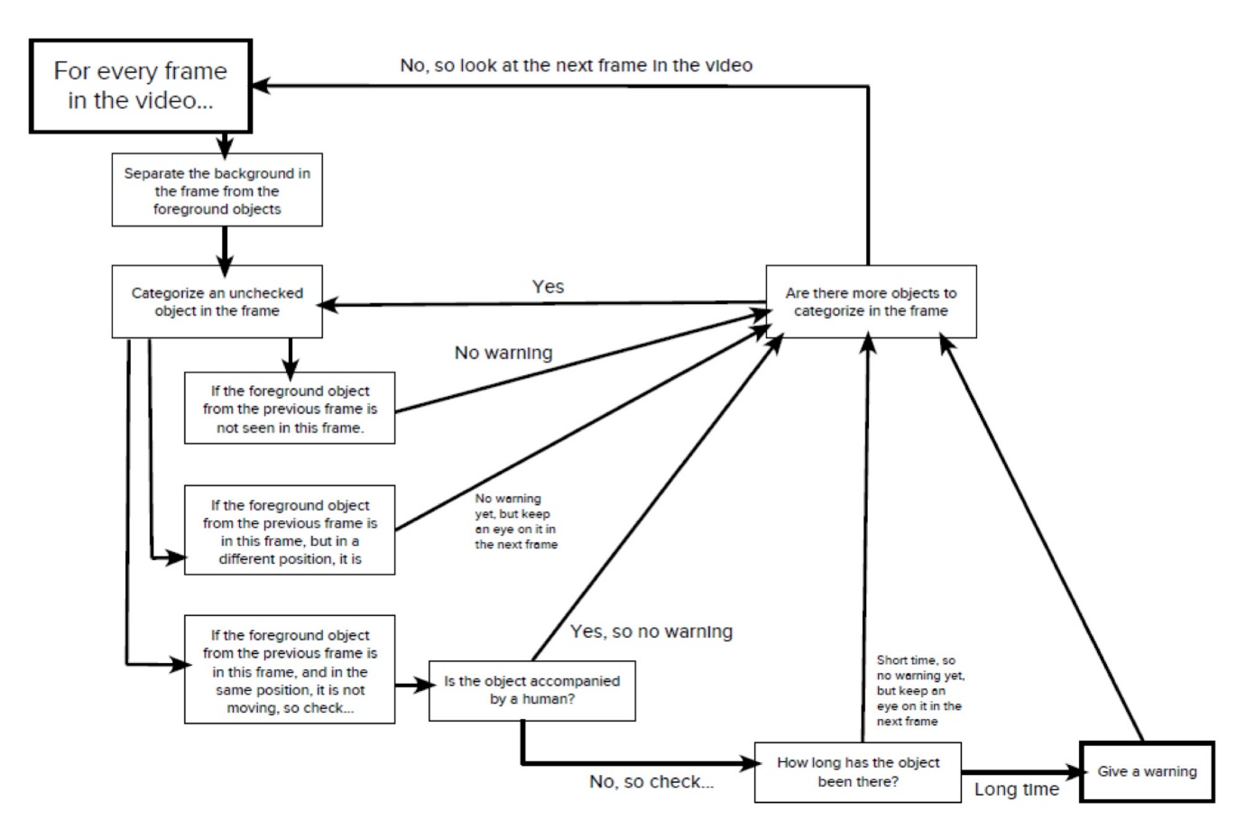

**1 / 1 point**



The algorithm generates a warning.



 The algorithm checks to see how long the luggage has been moving.



No warning is given, and the algorithm checks if there are more objects to categorize in the frame.



The algorithm checks to see if the luggage is accompanied by a human.

**Correct**

Correct! The algorithm shows that if an object has been moved the focus should shift to checking other objects.

**4.**

Question 4

Since computer-based solutions require questions that are specific and quantifiable, which one of the following questions is **most** appropriate for a computer-based solution?

**1 / 1 point**



What kind of behavior is suspicious?



How many people have entered the airport in the past two hours?



Why is flying better than driving a car?



What kind of luggage is the most aesthetically pleasing?

**Correct**

Correct! This question is specific and quantifiable – it is asking about how many people have entered within a specific time frame.

**5.**

Question 5

What is an algorithm? Choose the best answer:

**1 / 1 point**



The process of identifying parts of a problem that can be ignored when approaching a problem.



The breaking down of a large, complex problem, into smaller more manageable problem.



The process of identifying patterns that can lead you to a potential solution.



A process or defined set of rules used by a computer for solving an identified problem.

**Correct**

Correct! Algorithms determine a process or a set of rules that a computer can follow.